Regular Meeting
THURSDAY December 11th, 2025 – following Weed District Mtg
Snively Law Office – Hardin, MT
802 West 3rd Street

- Call to Order: The Big Horn Conservation District meeting was called to order by Chairman Steve Schanaman at 1:30 p.m. on Thursday, December 11, 2025 at the Snively Law Office in Hardin, MT. Other members present was Vice Chairman Phillip Miller, Treasurer Dan Lowe, supervisors Austin Pitsch, Roy Neal, and Associate Supervisor Bill Hodges. Also present was NRCS representative Seanna Torkse, Big Horn County Extension Agent Andrea Barry, guests Gus and Jesse Murdock and Jeremiah Jabs, and BHCD Administrator Kylie Shumway.
- Public Comment: As there was no response to call for public comment, the chairman proceeded with the meeting.
- Approval of Minutes: Due to a necessary modification, the November minutes were tabled for approval until January.
- Officers’ Report:
  - Treasurer
    - Dan Lowe presented the following bank balances: County Mill Levy Account $79,550.10, FIB Checking Account $28,131.93, WIS Account $70,440.88 and the Certificate of Deposits $16,790.70.
    - Dan Lowe presented the following bills for payment:
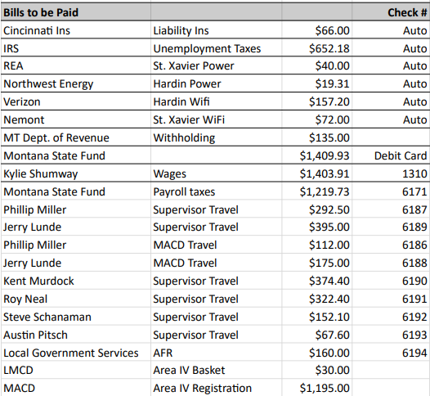

    - Austin Pitsch seconded the motion; as there was no opposition or discussion, the motion carried.
- Board and committee reports:
  - Conservation District Bureau – included in packet
- New Business:
  - Field Report
    - Local Workgroup Meeting
      - Seanna Torske asked the Board what they would like to do with the 2026 Local Workgroup Meeting. The Board voted to hold the meeting but have it more as an ‘update’ meeting on where programs stand.
  - MACD Update
    - Kylie Shumway, Phillip Miller, Jerry Lunde and Steve Schanaman all attended the MACD meeting in Billings. Phillip Miller updated the Board on the 310 workshops that he attended.
  - NACD Registration Open
    - Kylie Shumway is approved to go to San Antonio.
  - Supervisor Travel
    - Steve – MACD Phillip Miller motioned to pay out the remainder of Steve Schanaman’s mileage. Austin Pitsch seconded the motion; as there was no opposition or discussion, the motion carried.
- Old Business:
  - Mailbox
    - Austin Pitsch is going to follow up.
  - 310 Realtor Workshop
    - Kylie Shumway and Tyla Kiehl will investigate funding assistance for the venue.
  - Workmosis
    - The AFR’s are still in progress.
- Other Business: Austin Pitsch motioned for the Board to pay $30 to Lower Musselshell CD for the basket at the MACD. Phillip Miller seconded the motion; as there was no opposition or discussion, the motion carried.
- CLOSED SESSION
- Public Comment: As there was no public comment, Chairman Steve Schanaman adjourned the meeting at 3 p.m. The next BHCD meeting will be held on Thursday, January 8th at the new office location, the Snively Law Office at 1 p.m.

