Regular Meeting
THURSDAY March 5th, 2026 – following Weed District Mtg
Big Horn County Courthouse

- Call to Order: The Big Horn Conservation District meeting was called to order by Vice Chairman Phillip Miller at 2:20 p.m. Other supervisors present were Roy Neal, Kent Murdock, Austin Pitsch and Associate Supervisor Bill Hodges. Also present were NRCS representatives Seanna Torske, Evan Van Order, and Guthrie Ziebarth, Big Horn County Extension agent Andrea Barry, Weed District representatives Scott Bockness and Tom Pratt, and visitor Jeremiah Jabs.
- Public Comment: As there was no response to call for public comment, the chairman proceeded with the meeting.
- Approval of Minutes: Austin Pitsch motioned to approve February’s minutes as mailed/emailed. Kent Murdock seconded the motion; as there was no opposition or discussion, the motion carried.
- Officers’ Report:
  - Treasurer
    - As Dan Lowe was not present, Kylie Shumway presented the following report: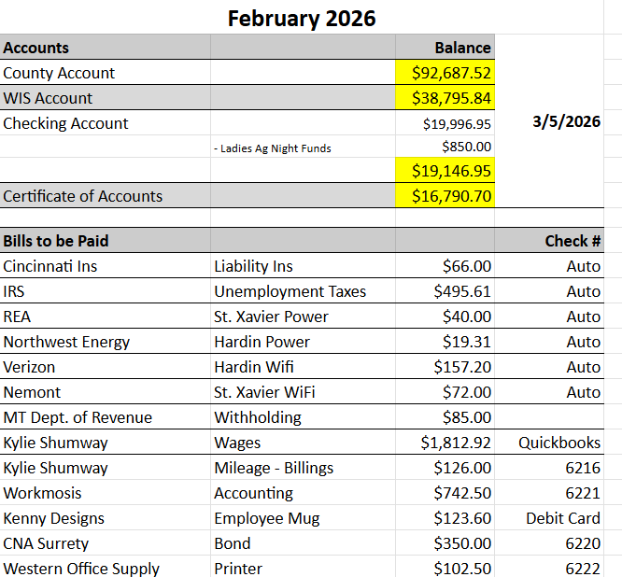
      - Roy Neal motioned to approve the following report. Austin Pitsch seconded the motion; as there was no discussion or opposition, the motion carried.
- Board and committee reports:
  - Conservation District Bureau – included in packet
- New Business:
  - Field Report
    - Seanna Torske presented the Field Report and reviewed the following Equip applications:
      - David D Pitsch
        - Flood to sprinkler irrigation; 111.5 ac
      - Byron Stimpson
        - Ventenata and sulfur cinquefoil spray, 3671.2 ac
      - Clay Gregory
        - Ventenata spray and spring development, 211.4 ac
      - Vickie MacCarty
        - Ventenata spray, 1471.4 ac
      - Jeremy Not Afraid
        - Ventenata and sulfur cinquefoil spray, 704.9 ac
    - Roy Neal motioned to approve and sign all applications. Austin Pitsch seconded the motion; as there was no opposition or discussion, the motion carried.
  - Yellowstone River Council Mtg Miles City Update - tabled
  - Reserved Water Update
- Old Business:
  - Mailbox
    - Phillip Miller mentioned to connect with Roy Neal about a contact to possibly build one.
  - Arbor Day Event Update
    - Kylie Shumway connected with the Board on where she was at with the planning, and presented a couple of new ideas. Nothing is set in stone, but they agreed that she is on the right track and to continue planning.
  - Workmosis – Payroll Update
    - Kylie Shumway and Abby with Workmosis were able to get her paid successfully for the month of February. The next step is to figure out the returning employees and then add whomever is hired.
  - AIS Job Descriptions – tabled
  - NACD Convention
    - Kylie Shumway represented the BHCD in San Antonio. The biggest measured being delivered from DNRC is that they are wanting the district to spend the CDA money. The other big push was for more social media outreach. Kylie Shumway presented the possibility of hiring a part time employee to run social media for the district with the 2027 CDA funding.
- Other Business: None
- Public Comment: As there was no public comment, the meeting was adjourned at 3:16 p.m. The next meeting will be held following the Weed District meeting on Thursday, April 2nd at the Snively Law Office.

