Regular Meeting
THURSDAY April 2nd, 2026 – following Weed District Mtg
Snively Law Office – Hardin, MT
802 West 3rd Street
- Call to Order: The Big Horn County Weed District meeting was called to order by Chairman Steve Schanaman at 1:04 p.m. on Thursday, March 5, 2026, at the Snively Law Office. Supervisors present included Vice Chairman Phillip Miller, supervisors Dan Lowe and Austin Pitsch, and associate supervisor Bill Hodges. Also present were Weed District representatives Scott Bockness and Tom Pratt, NRCS representative Seanna Tosrke, Extension Agent Andrea Barry and BHCD Administrator Kylie Shumway. Marvin Stops Jr. with the Crow Department of Agriculture, Jacob Stops attended Woody Wagenaar attended as members of the public to discuss 310 Law and Woody Invasives.
- Public Comment: As there was no response to call for public comment, the chairman proceeded with the meeting.
- Approval of Minutes: Phillip Miller motioned to approve the minutes as mailed/emailed. Dan Lowe seconded the motion; as there was no discussion or opposition, the motion carried.
- Officers’ Report:
  - Treasurer Dan Lowe presented the following bank balances: County Mill Levy account $92,678.52, WIS Checking $59,005.58, First Interstate Checking $16,541.95 and the Certificate of Accounts $16,790.70 and motion for the following bills to be paid: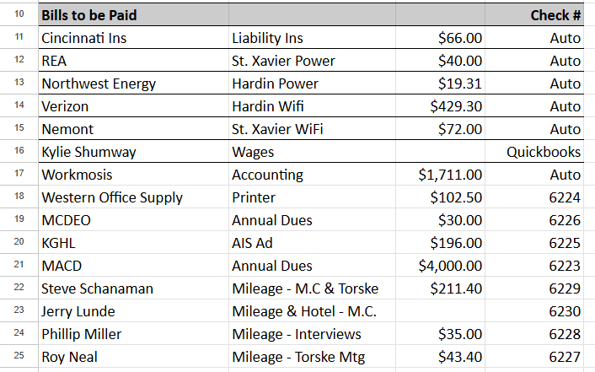
  - Roy Neal seconded the motion; as there was no discussion or opposition , the motion carried.
- Board and committee reports:
  - Conservation District Bureau – included in packet
- New Business:
  - 310 – Project Telephone Company
    - Phillip Miller motioned to approve that application is not a motion as proposed. Austin Pitsch seconded the motion. There was discussion regarding if something unforeseen happened thus creating a project and how the Board would continue should that be the case.
  - 310 – Laughery
    - Phillip Miller motioned to approve the complaint as a project. Dan Lowe seconded the motion; as there was no opposition or discussion, the motion carried. Kylie Shumway has a site visit already set up with the landowner for her and a couple of board members to go investigate/educate. Marvin Stops, with the Crow Department of Agriculture attended the meeting to discuss the 310 process and voice that he would also like to attend the site visit.
  - 310 – Big Horn River Alliance
    - Austin Pitsch motioned to approve the application as a project. Phillip Miller seconded the motion; as there was no opposition or discussion, the motion carried. Kylie Shumway will connect with Mike Sanctuary and/or Jim Chalmers for a site visit.
  - Snively Lease Agreement
    - Phillip Miller motioned to approve another years lease with Robert Snively. Austin Pitsch seconded the motion; as there was no opposition or discussion, the motion carried.
    - Liability/Renters Insurance: Austin Pitsch motioned for Kylie Shumway to acquire insurance to cover the office space. Roy Neal seconded the motion; as there was no discussion or opposition, the motion carried.
  - AIS 2026
    - Paperwork – Austin Pitsch motioned to approve that the overtime limit would 15 hours per pay period. Any overtime after that limit would require approval from the board. Roy Neal seconded the motion; as there was no opposition or discussion, the motion carrier.
    - Opening Day – Kylie Shumway invited any board member to visit the opening day luncheon/gathering with the AIS crew at the Fly Creek Station on April 11th from noon to two-ish.
  - Field Report – Seanna Torske presented the Field Report along with (4) Equips and (3) CSP’s. Roy Neal motioned to approve all applications. Phillip Miller seconded the motion; as there was no opposition or discussion, the motion carried.
- Old Business:
  - Woody Invasive Tour – Molly Masters
    - Molly Masters joined the meeting to discuss in further detail the Woody Invasives Tour on the Yellowstone River this coming July. She offered to write out the grant with Board approval for this year, with the understanding that in the future, if they seek BHCD assistance on the grant, the board wanted the Big Horn River to be a part of the tour. Roy Neal motioned to approve that this year, Molly Masters with the Missouri River Council would write the grant, with Kylie Shumway handling the funds. Phillip Miller seconded the motion; as there was no opposition or discussion, the motion carried.
  - Mailbox
    - Kylie Shumway received the new mailbox; she just needs to bring the post hole digger.
  - Tree Pick Up – May 11th in Billings
  - Arbor Day Event – May 16th in the Food Bank Parking Lot
  - Workmosis Update
    - Kylie sick Leave – Kylie Shumway had not been receiving sick leave. Roy Neal motioned for her to begin accruing starting on January 1, 2026. Austin Pitsch seconded the motion; as there was no opposition or discussion, the motion carried.
- Other Business: It was discussed and approved that Kylie Shumway set up the monthly printing invoices as auto payment.
- Public Comment: As there was no further public comment, the meeting was adjourned by Chairman Steve Schanaman at 3:45 p.m.

The next meeting will be held on Thursday May 7th, 2026 at the Snively Law Office, beginning with the Weed District meeting at 1 p.m.

