Regular Meeting
THURSDAY February 5th, 2026 – following Weed District Mtg
Snively Law Office – Hardin, MT
802 West 3rd Street

- Call to Order: The Big Horn County Weed District meeting was called to order by Chairman Steve Schanaman at 1:30 p.m. at the Snively Law Office. Also present was Vice Chairman Phillip Miller, Treasurer Dan Lowe, supervisors Austin Pitsch, Jerry Lunde, Kent Murdock, Roy Neal and Associate supervisor Bill Hodges. Also present was Scott Bockness, Tom Pratt, NRCS representative Seanna Torske and BHCD Admin Kylie Shumway.
- Public Comment: As there was no response to call for public comment, the chairman proceeded with the meeting.
- Approval of Minutes: Jerry Lunde motioned to approve the January meetings with the following addition: “At the October meeting in Great Falls, Fish, Wildlife and Parks alluded to a ‘contract enhancement’, having the BHCD under the impression that more money was available. However, this was not the case and there is no more money available.” The motion was seconded by Phillip Miller; as there was no opposition or discussion, the motion carried with the modification.
- Officers’ Report:
  - Treasurer
    - Treasurer Dan Lowe presented the following bank balances: County Mill Levy account $92,139.84, WIS Checking $44,926.44, First Interstate Checking $25,208.49 and the Certificate of Accounts $16,790.70.
    - Dan Lowe motioned for the following bills to be paid:
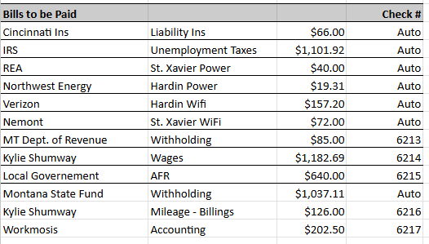

    - Phillip Miller motioned to approve the bills to be paid. The motion was seconded by Steve Schanaman; as there was no opposition or discussion, the motion carried
- Board and committee reports:
  - Conservation District Bureau – included in packet
- New Business:
  - Field Report – Seanna Torkse presented the Field Report
    - There were 7 EQIP Applications for the Board to review. Phillip Miller motioned to approve all seven applications for signature. Jerry Lunde seconded the motion; as there was no opposition or discussion, the motion carried.
  - Woody Invasive Tour
    - Molly Masters and Dan Rostad with the Yellowstone River Council reached out to Kylie Shumway regarding a project planned for July. They are searching for a Conservation District to host a DNRC Mini Grant to help with the costs. Austin Pitsch motioned to add some stipulations. Kylie Shumway will reach out to Molly and Dan and discuss further with them.
  - Arbor Day/District Donation
    - Kylie Shumway would like to host an Arbor Day event for the community beginning of May. She had reached out to Elle Ross with the Food Bank, and Austin Pitsch had been in touch with one of the local nurseries for possible donations. They Board would sponsor a raffle for gift certificates to all the other local nurseries, and for every extra dollar donated to the Food Bank would equal another tree. The main goal would be to support the community and get extra roots in the soil. Kylie will begin to plan and have an outline available to the Board at the March meeting.
  - AIS 2026
    - Site Lead Job Description – tabled. Kylie Shumway will reach out to Caitlin Overland again for legal counsel.
- Old Business:
  - Mailbox
    - Phillip Miller motioned for Kylie Shumway to reach out to Randy Malensek. The Board would like to keep our mailbox ‘local’. Kent Murdock seconded the motion; as there was no opposition or discussion, the motion carried.
  - Workmosis
    - AFR’s – Kylie Shumway reported that the AFR’s were caught up, and the District was in the green!
    - 2026 Payroll – It was agreed that Kylie Shumway and Steve Schanaman sign off on Payroll reports.
- Other Business:
  - Filing Documents
    - Phillip Miller, Roy Neal and Kylie Shumway will form a committee to go through the archives and decide what should be kept, and what can possibly be shredded.
- Public Comment: As there was no public comment, the meeting was adjourned at 3:35 p.m. and moved into Closed Session.

The next meeting will be held on Thursday, March 5th at the COURTHOUSE, beginning with the Local Work Group meeting at 1 p.m.

