Regular Meeting
THURSDAY January 8th, 2026 – following Weed District Mtg
Snively Law Office – Hardin, MT
802 West 3rd Street

- Call to Order: The Big Horn Conservation Meeting was called to order by Chairman Steve Schanaman at 1:30 p.m. on Thursday, January 8th at the Snively Law Office. The meeting was held intermittently with the Weed District meeting. Other supervisors present was Vice Chairman Phillip Miller, Treasurer Dan Lowe, supervisors Kent Murdock, Austin Pitsch and Jerry Lunde, and associate supervisor Bill Hodges. Also present was Montana Invasive Species coordinator Megan Hoyer, Big Horn County Extension agent Andrea Barry, NRCS representative Seanna Torske, and BHCD Administrator Kylie Shumway.
- Public Comment: As there was no response to call for public comment, the chairman proceeded with the meeting.
- Approval of Minutes:
  - The November meeting had been tabled for approval pending a modification. Jerry Lunde motioned to approve as modified. Phillip Miller seconded the motion; as there was no opposition or discussion, the motion carried.
  - Jerry Lunde motioned to approve the December minutes as emailed/mailed. The motion was seconded by Phillip Miller; as there was no opposition or discussion, the motion carried.
- Officers’ Report:
  - Treasurer
    - Treasurer Dan Lowe presented the following bank balances: County Mill Levy account $92,139.84, WIS Checking $70,184.40, First Interstate Checking $17,470.18 and the Certificate of Accounts $16,790.70.
  - Bills to be presented:
    - 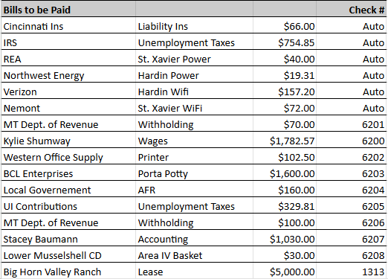
  - Phillip Miller motioned to approve the bills to be paid. The motion was seconded by Steve Schanaman; as there was no opposition or discussion, the motion carried
- Board and committee reports:
  - Conservation District Bureau – included in packet
- New Business:
  - Field Report – Seanna Torske presented the Field Report to the Board
  - Soil Health Symposium
    - Roy Neal will attend the Symposium. The BHCD would also sponsor their annual ticket at the Ladies Ag Night.
  - AIS 2026
    - FWP Contract Signature – Roy Neal motioned to approve for signature with the modification of the St. Xavier end date be changed to September 7th. Phillip Miller seconded the motion; as there was no opposition or discussion, the motion carried.
    - St. Xavier Lease Signature – Phillip Miller motioned to sign the lease for the 2026 season. Jerry Lunde seconded the motion; as there was no opposition or discussion, the motion carried.
    - Employee Job Description
      - Kylie Shumway presented modifications to the Job Description. She will update and send out the revised version for approval.
    - Site Lead Job Description
      - Kylie Shumway presented modifications to the Job Description. She will update and send out the revised version for approval.
- Old Business:
  - Mailbox – Paul Zelka mentioned that he has begun the project and is hoping to have it completed the following week.
  - 310 Realtor Workshop – It was discussed the growing size of the workshop. The Board would prefer to simplify the workshop to a more local, intimate setting.
  - Workmosis – Progress is still in motion. The AFR’s are almost caught up, and Kylie will meet with Abby regarding getting payroll moved over before the stations open.
  - Verizon - Kylie Shumway was able to get the router working at the office. There is now wifi, a desk phone, and 3 cell phones, with an updated bill to $218 a month.
- Other Business:
  - CLOSED SESSION – Kylie Shumway Evaluation
Public Comment: Chairman Steve Schanaman adjourned the meeting at 3:45 p.m. and moved into CLOSED SESSION. The next meeting will be held on February 5th, following the Weed District meeting.

