Save the Date!!!

**What: Annual Big Horn County Local Work Group Meeting When: Thursday, February 13th, 2025 1pm.**

**Where: Big Horn County Courthouse Basement Meeting Room 121 Third Street West, Hardin MT**

The Big Horn County Local Work Group will meet on Thursday, February 13th, 2025, at 1:00 p.m. at the Big Horn County Courthouse Basement Meeting Room, 121 Third Street West in Hardin.

The purpose of the local work group meeting is to develop a Big Horn County conservation needs assessment that will identify priority resource agricultural and natural resource concerns of the county, including high-priority areas needing assistance, and identify Natural Resources Conservation Service programs conservation practices. Anyone with an interest and familiarity with agricultural and natural resource issues in the community is encouraged to attend and provide input. **Local Work Group meetings are open to the public. If you cannot attend this meeting in-person, a questionnaire can be picked up the Big Horn County USDA Service Center and completed prior to the meeting.**

The Big Horn Conservation District’s monthly board meeting will be held at the Big Horn County Courthouse basement meeting room following this meeting, and the monthly Conservation District Board meetings are also open to the public.

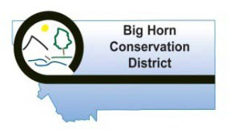

***USDA-NRCS provides reasonable accommodations for all persons with disabilities to participate in NRCS programs and activities. If you require special accommodations, please contact the Hardin NRCS Field Office at: (406) 665-3442, ext. 3, no later than February 7th, 2025.***

***USDA is an equal opportunity employer, provider, and lender.***